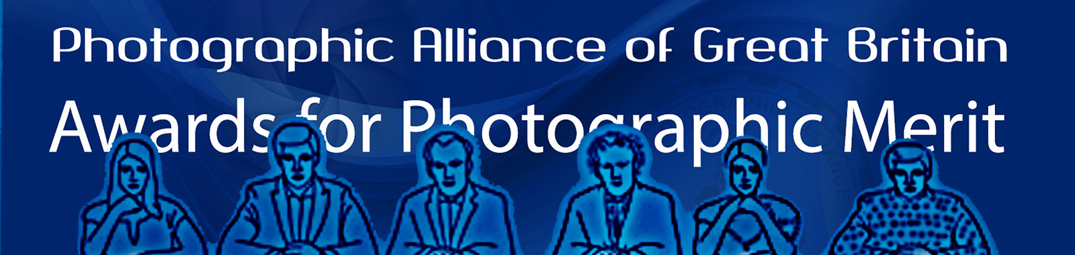
BPAGB - CPAGB – DPAGB – EPAGB – MPAGB
EVENT 3 - All Day Workshop Assessment Day Sun 12th Jan 2025 at Victoria Hall, Dunblane. This FREE event must be pre-booked.
SPF PAGB Awards Assessment Day for Print & PDIs being held at Dunblane, Sun 12th Jan 2025
This is an all-day FREE event starting at 10.00am, and being run at Victoria Hall, Dundblane, for individuals to have their prints and images assessed so spaces require to be pre-booked by 21st Dec although this event is likely to be full before then so don’t delay if you wish a space.
Priority will be given to those of you who have already submitted an Application Form to the PAGB for the Adjudication in April 2025 at Dunblane. We will then give priority to those who think they are ready to apply for April 2025, who have done the necessary pre-qualification requirements. Otherwise, spaces will be allocated on a first come, first served basis. We can accommodate observers, but observers must also pre-book.
I will acknowledge receipt of your booking form and then confirm if you have a space on the workshop once the 21st Dec deadline has passed, or your pre-qualification has been confirmed.
This event will be run in our normal format with stations of assessors who will give you critique on your work with regard to the level you have applied for or are thinking of applying for. You will be allocated two stations of assessors and time slots am/pm, after that you can seek advice from anyone who is free at the end of each session. Those who have already applied FOR April 2025 can bring the number of photos required for the level they have applied for, plus up to 5 additional (e.g. CPAGB would by 10+5). Those who have not yet applied can have up to 7 photos assessed. Prints do not require to be mounted. PDIs should be sized as 1600x1200 or smaller, and in a folder on a USB driver ready to be downloaded onto our laptop.
The assessors who are attending, will include Rod Wheelans Chairman of the PAGB APMs & Libby Smith SPF’s PAGB Awards Officer and PAGB APM Sub-Committee member, together with Richard Speirs PAGB APM Sub-Committee member and Gerald Chamberlin NCPF PAGB Awards Officer, and a number of SPF APM assessors. Tea/coffee making supplies will be available for a donation. Bring your own packed lunch, or available from local vendors within walking distance.
If you wish to attend, you require to book your space as soon as possible to ensure a space, answering all of the questions given on the following booking form and send by email to- libby.neilsmith@btinternet.com
by 21st December at the latest.
BOOKING FORM - Dunblane
Please feel free to copy the following into your email message rather than sending the form if easier
YOUR NAME
YOUR CLUB
(Must be an SPF Member Club)
LEVEL YOU ARE GOING FOR
(e.g. BPAGB, CPAGB, DPAGB, EPAGB, MPAGB)
PLEASE DELETE ONE OPTION FROM EACH OF THE FOLLOWING -
I WISH WORK ASSESSED AT - EVENT on Sunday 12th Jan 2025 |  | YES/NO
IF ‘YES’ - I WILL BE BRINGING (i.e. the medium you are applying in) – you must bring only one medium |  | PRINTS/PDIS
I WISH TO OBSERVE ONLY |  | YES/NO
I HAVE ALREADY APPLIED FOR APR 2025 (i.e. submitted a signed application form to the PAGB) |  | YES/NO
I HAVE ALREADY APPLIED FOR NOV 2025 (i.e. submitted a signed application form to the PAGB) |  | YES/NO
I HAVE NOT YET APPLIED |  | YES/NO
I WISH TO APPLY FOR APR 25 PAGB ADJUDICATION - HOSTED BY SPF  (I have done the necessary Pre-Qualification requirements – see document below for full details) |  | YES/NO
I WISH TO APPLY FOR APR 25 PAGB ADJUDICATION - HOSTED BY SPF  (I Don’t know If I have done the necessary SPF Pre-Qualification requirements – see document below for full details) |  | YES/NO
I AM NOT YET SURE WHEN I WILL APPLY |  | YES/NO

Been on the PAGB’s website? You also need to read this Leaflet for SPF Pre-Qualification Details (Stage 1) to find out how to be eligible for a signed Application Form from Libby, and submit to the PAGB for a space on a forthcoming PAGB Awards Adjudication – (follow the link or copy to your browser)
https://www.scottish-photographic-federation.org/sites/default/files/downloads/spf_pre-qualification_and_pagb_awards_general_info_aug_2024_0.pdf
Also see PAGB Awards Leaflet 1 (V Dec 2023) for more on Stage 2 of the process
https://www.scottish-photographic-federation.org/sites/default/files/downloads/apm_leaflet_1_dec_2023_0.pdf
and PAGB Awards Leaflet 1 FAQ Supplement (V Jan 2024)
https://www.scottish-photographic-federation.org/sites/default/files/downloads/apm_leaflet_1-faq_jan_2024_0.pdf

NEED HELP? – HAVE QUESTIONS? – WANT TO FIND OUT MORE?
CONTACT LIBBY ON - libby.neilsmith@btinternet.com
OR for all up-to-date info about the PAGB Awards scheme visit the SPF website’s dedicated webpage
https://www.scottish-photographic-federation.org/pagb-awards-applying
OR for loads of successful SPF applicant’s galleries
https://www.scottish-photographic-federation.org/pagb-awards-results

