Scottish Photographic Federation host the
PAGB Awards for Photographic Merit
on Saturday and Sunday 26th & 27th Nov 2016
At Cameron Hall, Beaconhurst School,
52 Kenilworth Road, Bridge of Allan, Stirling, FK9 4RR
www.beaconhurst.com Please do not contact the school direct.
There are Railway Stations in Bridge of Allan (1 mile) and in Stirling (3 miles). Taxis & Buses available.

Tickets are now available for spectators at a cost of £8.00 which includes Teas/Coffees throughout the day.
This opportunity to host this event only comes around every 7 years, so if you are interested in the PAGB Awards scheme, or think you might be in the future, it is an event not to miss.
Doors to Reception area open 9.00am with judging commencing at 10.30am. Print Entries being delivered on the day must be handed in by 9.30am and must include a copy of the Entry Form If you plan to stay overnight there are hotels nearby in Bridge of Allan and Stirling.
Catering Arrangements Tea / coffee will be supplied free to every ticket holder. The venue will be unable to provide any other refreshments so you are highly recommended to bring your own lunch. There are also a number of places close to the venue where refreshments can be purchased. Please note the lunch break will only be for approximately one hour and we are unable to specify precisely when this will be taken.
Tickets can be purchased by completing and sending the following, together with a Stamped Addressed Envelope, with your cheque made payable to ‘Scottish Photographic Federation’ to - Reception Secretary, Joe Prior 24 Langcroft Road, Glasgow, G51 4JB 0141 883 3131

Number of Tickets Required @ £8
(inc Tea/Coffee)
Name  Address | . ……………………………………………………………………………  . ……………………………………………………………………………
Contact Tel.
Contact E-Mail

Some images from the successful panels of Eion Johnston DPAGB, Edinburgh (Top) and Gordon Rae MPAGB, Dumfries (Bottom). The full panels, along with other successful candidate’s work can be viewed on the SPF Website
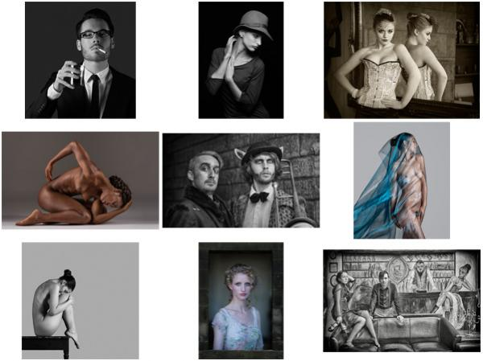
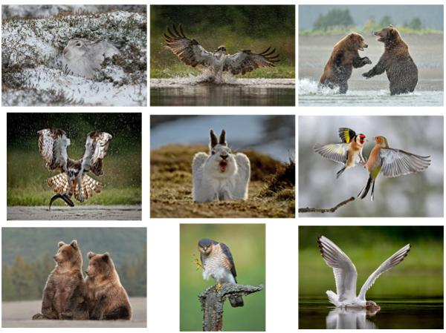
And, from the successful panels of Nicola Shepherd CPAGB, St Andrews; Guardian Angel
and Chris Briggs CPAGB, Donside; Short Eared Owl Hunting
